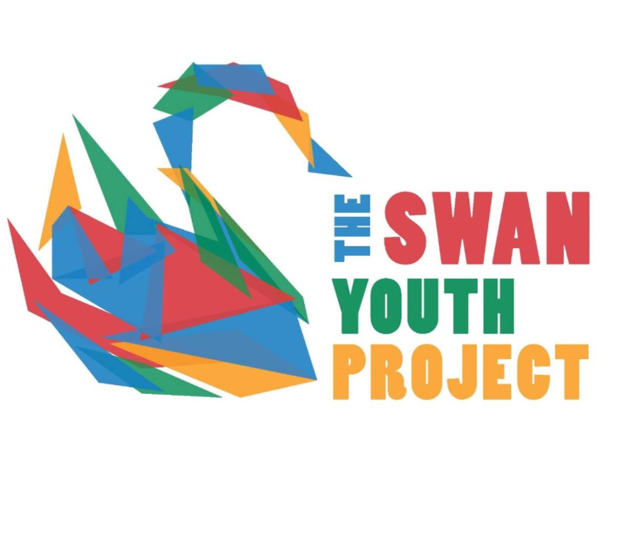 KEW GARDENS VISIT PERMISSION FORM
Event: Kew Gardens Visit (8:45-3:30) | Date: Saturday 25th May 2024
Location: Royal Botanic Gardens, Kew | Cost: £10
Drop off: Front Entrance to Berkhamsted Train Station, by 8:45am | Pick up: Front Entrance to Berkhamsted Train Station, 3:30pm
Transport details: Taking the train to the gardens, with members of staff | Activity: Kew Gardens Visit
What to bring: Packed Lunch, Water Bottle and appropriate clothing for the weather. | Organiser contact details: Imogen from Swan Youth Project email: imogen@swanyouthproject.co.uk

Please return this form to Swan Youth Project by 17th May 2024 (First come, first served)
Name of Young Person: ………………………………………………………….. D.O.B:…………………………………..
Event: Kew Gardens Visit
I have enclosed the full balance of £10
I have noted the arrangements above and agree to the child taking part. I understand that Swan Youth Project reserves the right to send any participants home if deemed necessary, and I will be responsible to collect them.

Emergency Contact: ………………………………………………….. Phone:…………………………………………………
Please tick relevant box:
- I give my permission for the child to walk to and from the location mentioned
- I will collect them at the end of the session.
- I am happy for The Swan Youth Project to use photos and videos of my child in promotional materials, funding applications, the Swan Youth Project website and other social media. (Name will never be included)

Signed: ………………………………………………………………………………. Date: ……………………………………..
Relationship to young person: ………………………………………………………………

