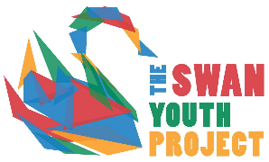

SAFEGUARDING POLICY & PROCEDURES FOR CHILD PROTECTION

At the Swan Youth Project we will follow this policy in every way possible. All of the Swan’s policies have been created with the aim in mind of benefiting the young people of Berkhamsted.
Time has been put into the creation of these policies to ensure legal and high youth work standards are met. All policies will be reviewed on an annual basis, unless otherwise deemed necessary, by both the Trustees of the Swan Youth Project and the Manager.

POLICY AUTHOR: PARUL DIX
POSITION HELD: MANAGER
DATE REVIEWED: 5th OCTOBER 2023 By Trustee Helen Rognaldsen
FUTURE REVIEW DATE: 5th OCTOBER 2024

The SWAN Youth Project Safeguarding policy and procedure for - Child Protection
1 Introduction
Safeguarding is everyone’s responsibility. The purpose of this document is to specify The SWAN Youth Project’s Safeguarding policy and procedures for the protection of children and young people. All staff working in direct contact with young people will have an annual Safeguarding training refresher delivered by the Manager. A child is defined as up to the age of 18. The document applies to all SWAN Youth Project Staff, including apprentices, trustees and volunteers, and the policy and procedures applies to all of The SWAN Youth Project’s activities.
All adults who come into contact with young people in their work have a duty of care to safeguard and promote their welfare. Child protection refers to the activity that is undertaken to protect specific children who are suffering, or are likely to suffer, significant harm.
The Children Act 2004 places a duty on organisations to safeguard and promote the well-being of young people. This includes the need to ensure that all adults who work with or on behalf of young people in organisations are competent, confident and safe to do so. (Guidance for Working together to safeguard children July 2018).
Safeguarding and promoting the welfare of children is defined for the purposes of this policy as:
▪ Protecting children from maltreatment
▪ Preventing impairment of children’s health or development
▪ Ensuring that children are growing up in circumstances consistent with the provision of safe and effective care
▪ Taking action to enable all children to have the best life chances.
The names of the Designated Safeguarding Leads are Parul Dix (Manager) and Sandra Swarbrick (Trustee).

2 Policy
The SWAN Youth Project seeks to provide an environment where everyone can work safely, and young people can engage with the charity’s activities and enjoy programmes provided through the work of the Charity or in partnership with other agencies and/or community voluntary sector organisations. It is the policy of The SWAN Youth Project to safeguard the welfare of young people in the work we do by protecting them from neglect, physical, sexual or emotional abuse. It is also The SWAN Youth Project’s policy to provide those working for or with the charity with a framework to operate within to keep everyone who is engaged in the Charity’s activities safe. It is therefore the SWAN Youth Project’s responsibility to:
▪ ensure that all staff, trustees, and volunteers (legally responsible adults) working with children, young people are carefully selected, are checked by the Disclosure and Barring Service (“DBS”) and have two appropriate references and understand and accept their responsibility for the safety of young people
▪ respond appropriately to all suspicions or allegations of abuse, and to ensure confidential information is restricted to the appropriate external agencies
▪ raise the awareness of relevant staff, partner organisations and volunteers of child protection issues
The Child protection policy and procedure also seeks to manage effectively the risks associated with activities and events involving young people by:
▪ completing a risk assessment process which involves identifying risks and means of reducing or eliminating these
▪ implementing the required actions identified by the risk assessment process and reviewing the effectiveness of these
▪ ensuring that the appropriate DBS or basic disclosure checks are conducted, depending on eligibility, for any individuals starting or moving into work which involves working with young people
▪ requiring new employees and individuals involved in working with young people and to familiarise themselves with the content of this policy and the associated code of behaviour
Ensure through training that all staff are aware of and committed to the Safeguarding and Child protection Policy and Procedure

Responsibilities
The implementation of this policy is mandatory across all areas of the Charity. Specific responsibilities are outlined below:
The Leadership Team (Includes Trustees and Manager) will ensure the policy and its accompanying procedures and practice guidelines are implemented. The Manager will report to the Trustees any safeguarding and or child protection issues which may arise and will ensure:
▪ the resources available to support staff on safeguarding/child protection issues are maintained
▪ that safeguarding implications are reviewed across the scope of the work the Charity delivers to young people, which may result in a change of operational practice
▪ safeguarding is considered in all appointments of staff (to include trustees and volunteers)
▪ all new staff members and volunteers have the required disclosure certificate in place if engaging in regulated activity with young people and that they cooperate with the internal DBS procedure to include checking ID and provision of signed copies of documents with their contract of employment to the Trustees.
▪ training of staff is delivered as regularly as is necessary

Manager and Trustees are responsible for:
▪ ensuring that staff are able to discuss safeguarding, child protection and abuse issues confidentially and receive guidance and support on action if situations arise
▪ ensuring the Safeguarding policy is implemented locally and that procedures to support the policy are set up as outlined, complied with and communicated
▪ ensuring the referral of all safeguarding, child protection issues to the Designated Safeguarding Lead, (this may be as simple as discussing a hypothetical issue to protect identities)
▪ ensuring all reporting staff are aware of their roles and responsibilities under this policy. This will form part of their induction
Any behaviour by a Trustee, member of staff, apprentice or volunteer that contravenes the terms of this policy and procedure may be considered for disciplinary action, which in turn may lead to dismissal for staff and ending of contracts for apprentices and volunteers and for Trustees being removed from the Trustee Board.

Work with Young People
The SWAN Youth Project requires all those working directly with young people on behalf of the charity in any situation to follow the procedures below, to create a safe environment in which to work with them.
Guidance for safer working practice; The word “session” is used below to cover all delivery of our work and “staff” includes apprentices, Trustees, employees, and volunteers.
Staff working with children, young people should:
▪ ensure there is a minimum of two staff with legal responsibility present
▪ wherever possible, staff should avoid being alone with young people and staff shouldn’t take them to their own home. Staff shouldn’t offer a lift to a young person unless they have written parental consent, or a second adult (preferably group leader) is present
▪ all accidents/incidents involving staff or participants should be recorded using the Charity’s accident forms immediately or as soon as practicably possible (Appendix 6)

Good Practice to protect against allegations of abuse
Staff are responsible for reporting suspected cases of child abuse to the DSL. Staff, volunteers or Trustees shouldn’t:
▪ spend excessive amounts of time alone with young people away from others
▪ take young people to your own home
▪ offer a lift to a young person unless they have written parental consent, or a second adult (preferably group leader) is present. Where occasions arise where it is unavoidable that these things do happen, they should be done with the full knowledge and consent of someone in charge of the organisation and/or the young person’s parents/guardians.

Never:
▪ engage in rough physical activities including horseplay
▪ engage in sexually provocative activities
▪ allow or engage in inappropriate touching of any form. (Note: where contact is essential for H&S requirements, i.e., an outdoor instructor kitting up activity participant, this is done through clear communication, with participant consent and follows training guidelines)
▪ allow young people to use inappropriate language unchallenged
▪ make sexually suggestive comments about, or to a young person even in fun
▪ let an allegation a young person makes during a group session go unchallenged or unrecorded
▪ do things of a personal nature for young people that they can do themselves
▪ place yourself in a situation where you will be left alone with a young person. Always seek help from another worker
▪ if you do have to do things of a personal nature for young people (support, give lifts) particularly if they are very young or disabled, then you should obtain the full consent of their parents and ensure a second adult is present. In an emergency situation, which requires this type of help, parents should be fully informed as soon as is practicable

Photography and Interviews
Formal permission should be obtained for the use of any images of a young person; apart from child protection issues, photographs, and quotes/interviews that identify the person, are classed as personal information and, as such, are governed by Data Protection laws (see The SWAN Youth Project’s Data Protection policy and procedures)
Off-site and Residential Events: The SWAN Youth Project is not responsible for a young person while they are travelling independently to and from the event unless agreed with The SWAN Youth Project beforehand. It is the responsibility of the parent/guardian or to make appropriate travel arrangements for them where stated necessary by The SWAN Youth Project.

Signs of Abuse
Abuse and neglect are forms of maltreatment of a child. Somebody may abuse or neglect a young person by inflicting harm, or by failing to act to prevent harm. Young people may be abused in a family or in an institutional or community setting, by those known to them or, more rarely, by a stranger. They may be abused by an adult or adults, or another child or children. Some signs that could alert staff and volunteers to the fact that a young person at risk might be being abused include:
▪ unexplained bruising and injuries
▪ sexually explicit language and actions
▪ sudden changes in behaviour
▪ something a child has said
▪ a change observed over a long period of time e.g., losing weight or being increasingly dirty or unkempt
If a young person displays these signs, it does not necessarily mean that they are being abused. Similarly, there may not be any signs; you may just feel something is wrong. If you are worried, it is not your responsibility to decide if it is abuse, but it is your responsibility to act on your concerns and do something about it by reporting it appropriately. See Appendix 2 for Types of Abuse

Suspicions/Reports of Abuse
It is not the responsibility of staff or volunteers to deal with suspected abuse, but it is their responsibility to report concerns in line with guidance on reporting child abuse. You may find that these suspicions back up other recorded incidents. Remember, do not investigate – do report.
The following information covers different safeguarding scenarios – follow the one that is appropriate in the situation.
1. If a young person’s behaviour/appearance gives reason for concern or they have an unusual physical injury or they confide about abuse, the procedure below MUST be followed:
a. immediately informs the DSL/Manager or a Trustee of The SWAN Youth Project
b. uses the Incident Recording Process (Appendix 3) to make a record of your actions, include anything the young person said, anything you asked the child, and your observations. This may be used as evidence later. Record only the facts as you know them
c. ensures the child has access to an independent adult (e.g., teacher/group leader/youth worker)
d. if abuse is suspected, you should report concerns directly to the SWAN Youth Project DSL, Parul Dix. It is the responsibility of the Manager to inform the appropriate authorities.

The following are some key Do’s and Don’ts if a young person reports abuse: Always:
- Stay calm – ensure the young person is safe and feels safe
- Make notes and as soon as possible after the event write up a detailed account of what you and the young person at risk discussed
- Allow the young person to speak without interruption, accepting what you have been told. (This should not be seen as believing or disbelieving what you have been told)
- Reassure the young person that they are not to blame, tell them that they are right to tell you and that you will try to offer support – but do not promise to keep it a secret and tell the child it is your responsibility to inform others
- Tell the young person at risk that you will try to offer support, but you will have to pass the information on
- Alleviate feelings of guilt and isolation, without passing any judgement

Never:
- Rush into details that may be inappropriate
- Make promises you cannot keep
- Take sole responsibility – consult someone else so that you can protect the young person risk and gain support for yourself.

REPORTING A SAFEGUARDING CONCERN:
If you receive an allegation from an adult about another adult or yourself the procedure that MUST be followed is:
- Immediately informs the DSL/Manager or as Trustee of The SWAN Youth Project
- Records the facts as you know them and give a copy of the record to the DSL/Manager or Trustee
- If an allegation is suspected, concerns should be reported directly to the DSL/Manager or in her absence a Trustee of The SWAN Youth Project. It is then their responsibility of the to inform the appropriate authorities. Where appropriate a Safeguarding Referral form may be completed by the DSL.

REPORTING A SAFEGUARDING CONCERN:
If you receive a request for advice from anyone external of the Charity about suspected/reported abuse of a young person, the procedure that MUST be followed is:
- Advise them to make a note as soon as possible detailing the facts as known and, if they spoke with the young person at risk, what was discussed
- Advise them to contact the nearest Children’s Social Care with details of the concerns/report, including a copy of the written notes
- Immediately inform the DSL/Manager or Trustee
- Record the facts as you know them and give a copy of the record to the DSL/Manager or Trustee. Where appropriate a Safeguarding Referral form may be completed by the DSL.

REPORTING A SAFEGUARDING CONCERN:
If you are concerned that a young person may be subject to abuse or harm:
- Make a written, dated note of observations
- Immediately inform the DSL/Manager or Trustee as soon as possible, who will, within the appropriate timeframe, either make enquiries without raising the question of abuse and evaluate the matter and/or make a referral to the appropriate external authority. Where appropriate a Safeguarding Referral form may be completed by the DSL.

Referral Procedure
The following outlines the steps you should take if you are concerned that the behaviour of a member of staff or other person is threatening, or potentially threatening, the well-being of a young person.
a. If you are concerned that a member of staff is harming or abusing a young person you must report your concerns immediately to the DSL/Manager (if appropriate) or a Trustee. Where it is appropriate to do so, relevant HR procedures may be initiated, and/or a referral made to an external agency (i.e., The Safeguarding Hub)
b. If you suspect any other person is harming or abusing a young person you should contact the DSL/Manager or a Trustee. However, you can contact Children’s Services, or the Police. If you have urgent concerns about the safety of a young person and are unable to contact the DSL/Manager or a Trustee, do not hesitate to contact Children’s Services or the police. These external agencies will be in a position to determine an appropriate course of action
Making a Referral
If you are concerned that a young person may be at risk or has disclosed that they are being harmed, you should contact the DSL/Manager or a Trustee. The DSL/Manager or a Trustee will assess the concerns to determine whether to refer to an external agency, or whether it can be addressed via the Charity’s internal procedures. Where a referral is to be made externally, the DSL/Manager or a Trustee will report the matter to the authorities. The external agency will conduct their own investigation. Anonymity may not be maintained on reporting.
In the event of going on a day/residential activity, The SWAN Youth Project acknowledges Scotland’s safeguarding and Child Protection laws are different to those of England & Wales and will abide by these when it is appropriate to do so.
Radicalisation & Extremism
The threat from terrorism and extremism in the UK is real and can involve the exploitation of vulnerable young people. This can include involving them in extremist activity in the UK or abroad putting them in extreme danger. Young people are being targeted by adults who hold extreme views that advocate violence. There has also been an increase in far-right extremism, which can also draw them into violence.
The SWAN Youth Project staff, including apprentices, trustees and volunteers, working directly with young people must be aware of radicalisation and extremism and report any suspicions of radicalisation and extremism immediately to the Manager or Trustee. Radicalisation and extremism can put a young person at risk of being drawn into violence and criminal activity and has the potential to cause significant harm.
Radicalisation is a process by which an individual, or group comes to adopt increasingly extreme political, social, or religious ideals and aspirations that reject or undermine the status quo or undermine contemporary ideas and expressions of a nation.
Children and young people may become radicalised if they feel:
▪ isolated or lonely and wanting to belong
▪ unhappy about themselves and what others might think of them
▪ embarrassed or judged about their culture, gender, religion or race
▪ stressed or depressed
▪ fed up with being bullied or treated badly by other people or by society
▪ angry at other people or the government
▪ confused about what they are doing
▪ pressured to stand up for other people who are being oppressed
▪ the desire to be valued and respected
▪ there are few other options open to them
▪ no one is listening to them/have no voice

Extremism is when people have very strong opinions, and these could become extreme. People who have certain beliefs about politics or religions which are hateful, dangerous or against the law are often known as extremists. This harmful behaviour is called extremism.
Extremists might use violence and damage to express their views. And extremist racial or religious groups might use religion, hate, fear or violence to control and influence people. There are many groups and individuals who hold extremist views both within the UK and internationally, some are more dangerous than others and The SWAN Youth Project staff need to be aware of how they can affect young people in a negative way and what you should do to support young people who are in danger of being radicalised.
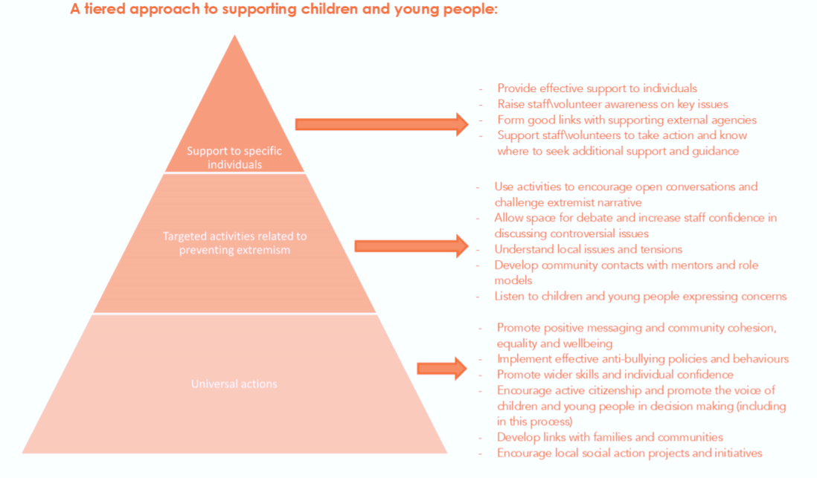
The SWAN Youth Project staff, including apprentices and volunteers, will be expected to have completed PREVENT awareness training at a minimum biannually to equip staff to identify children at risk of being drawn into terrorism and to challenge extremist ideas. Trustees and volunteers ideally will have completed the PREVENT awareness training if direct delivering youth provision to young people, however it is recognised this is not always practical and therefore a minimum requirement is that they have read this document and have acknowledged reading it.

Training
To assist implementation of the duty in section 26 of the Counter-Terrorism and Security Act 2015, the Government has produced a “Prevent e-learning training package” which is now available. This is introductory training. It provides a foundation on which to develop further knowledge around the risks of radicalisation and the roles involved in supporting those at risk. There is also a guidance document produced by the Government as per the following link: https://www.gov.uk/government/publications/prevent-duty-guidance/prevent-duty-guidance-for-england-and-wales-accessible

Further information
▪ For details of legislation and up to date information on Child Protection, see: Safeguarding children and young people
▪ The following local authority organisations are responsible for key inter-agency forums for child protection, safeguarding assessments and decisions at level and are identified on local government websites:
▪ Social Services Departments
▪ Local Safeguarding Children Board (LSCB)
▪ Multi Agency Safeguarding Hub (MASH)
▪ Radicalisation and Extremism - Prevent Duty Guidance, Preventing Violent Extremism
▪ NSPCC. A registered charity established to prevent cruelty to children. Help line for concerns about a child’s welfare 0808 800 5000
▪ Children England – A registered charity created by other charities aimed at creating a society where all children and young people are valued, protected and listened to, their rights are realised, and families are supported
▪ Child exploitation and Online Protection (CEOP)
▪ See Appendix five for The SWAN Youth Project safeguarding contacts

The SWAN Youth Project Supporting Policies and Procedures
The SWAN Youth Project has a duty, both in law and as a responsible organisation, to take reasonable care of young people coming into contact with the Charity’s activities. The Charity aims to adopt the highest possible standards and take all reasonable steps in relation to the safety and welfare of children and young people. The SWAN Youth Project is fully committed to meeting the requirements of safeguarding, in relation to young people, in order to ensure that they are safeguarded whilst enjoying opportunities to develop their full potential.
This policy should be read in conjunction with the following The SWAN Youth Project policies and procedures:
▪ Health and Safety
▪ Whistle Blowing
▪ Recruitment and Selection policy
▪ Anti-Bullying policy
▪ Complaints and Grievance Policy and procedure
▪ Incident forms
▪ Accident forms
▪ Data Protection Policy
▪ Disciplinary policy and procedure

The following legislation is relevant to this policy, either because it has influenced its introduction and/or its content:
▪ Health and Safety at Work Act 1974 https://www.hse.gov.uk/legislation/hswa.htm

▪ The Police Act 1997 https://www.legislation.gov.uk/ukpga/1997/50/contents

▪ Protection of Children Act 1999 https://www.legislation.gov.uk/ukpga/1999/14/2002-03-12

▪ Management of Health and Safety at Work Regulations 1999 https://www.legislation.gov.uk/uksi/1999/3242/contents/made

▪ The Human Rights Act 1998 https://www.legislation.gov.uk/ukpga/1998/42/contents

▪ Sexual Offences Act 2003 https://www.legislation.gov.uk/ukpga/2003/42/contents

▪ The Children Act 2004 https://www.legislation.gov.uk/ukpga/2004/31/contents

▪ Safeguarding Vulnerable Groups Act 2006 https://www.legislation.gov.uk/ukpga/2006/47/contents

▪ Equality Act 2010 https://www.legislation.gov.uk/ukpga/2010/15/contents

▪ Protection of Freedoms Act 2012 -The Protection of Freedoms Act 2012 is of particular importance as all decisions made to bar individuals from working with children or adults are now made by the Disclosure and Barring Service (DBS) under this legislation. https://www.legislation.gov.uk/ukpga/2012/9/contents/enacted

▪ GDPR and data protection act 2018 8 Review. This procedure will be reviewed and updated to reflect changes in legislation that would require The SWAN Youth Project to amend its policy and procedures. As a minimum, it will be reviewed annually. https://ico.org.uk/for-organisations/guide-to-data-protection/introduction-to-data-protection/about-the-dpa-2018/

▪ Counter-Terrorism and Security Act 2015 https://www.legislation.gov.uk/ukpga/2015/6/contents/enacted

Appendices:
Appendix 1 Membership Form
Appendix 2 Types of Abuse Appendix
Appendix 3 Incident Record Process
Appendix 4 A code of good practice
Appendix 5 The SWAN Youth Project Safeguarding Contacts list (Internal and General Public).
Appendix 6 Accident Report Form

APPENDIX 1: Member & Parent Consent Form
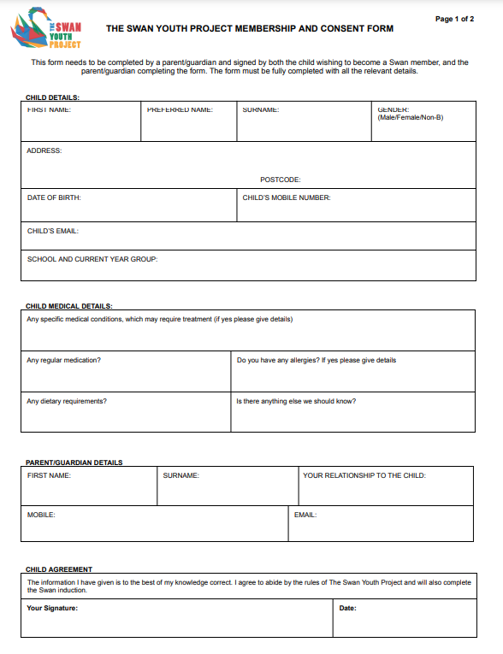

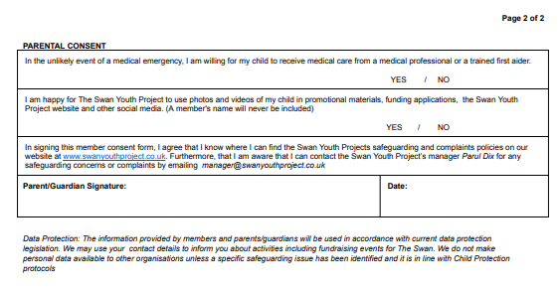

APPENDIX 2: Types of Abuse:
Abuse: A form of maltreatment of a child. Somebody may cause abuse or neglect a child by inflicting harm, or by failing to act to prevent harm. Children may be abused in a family or in an institutional or community setting by those known to them or, more rarely, by others (e.g., via the internet). They may be abused by an adult or adults, or another child or children.
Physical abuse: Physical abuse may involve hitting, shaking, throwing, poisoning, burning or scalding, drowning, suffocating, or otherwise causing physical harm to a young person. Physical harm may also be caused when a parent or carer fabricates the symptoms of, or deliberately induces, illness in a young person.
Emotional abuse: Emotional abuse is the persistent emotional maltreatment of a young person such as to cause severe and persistent adverse effects on their emotional development. It may involve conveying to them that they are worthless or unloved, inadequate, or valued only in so far as they meet the needs of another person. It may feature age or developmentally inappropriate expectations being imposed on young people. These may include interactions that are beyond their developmental capability, as well as overprotection and limitation of exploration and learning, or preventing them participating in normal social interaction. It may involve seeing or hearing the ill-treatment of another. It may involve serious bullying, causing young people frequently to feel frightened or in danger, or the exploitation or corruption of them. Some level of emotional abuse is involved in all types of maltreatment of a young person though it may occur alone.
Sexual Abuse & Sexual Exploitation: Sexual abuse involves forcing or enticing a young person to take part in sexual activities, including sexual exploitation, whether or not they are aware of what is happening, and whether it is for money or reward or not. The activities may involve physical contact, including penetrative contact (e.g., rape and buggery) or nonpenetrative acts. They may include non-contact activities, such as involving young people in seeing or receiving or sending sexually suggestive emails or text-messages, or inappropriate behaviour on the Internet, involving them looking at, or in the production of, pornographic material of watching sexual activities, or encouraging them to behave in sexually inappropriate ways.
Neglect: Neglect is the persistent failure to meet a young person basic physical and/or psychological needs, likely to result in the serious impairment of their health or development. Neglect may occur during pregnancy because of maternal substance abuse. Once a child is born, neglect may involve a parent or carer failing to:
▪ Provide adequate food, clothing and shelter, (including exclusion from home or abandonment)
▪ Protect a young person from physical and emotional harm or danger
▪ Ensure adequate supervision (including the use of inadequate caregivers) ▪ Ensure access to appropriate medical care or treatment
It may also include neglect of, or unresponsiveness to, a young person’s basic emotional needs.
Discriminatory Abuse: Including racial or sexual harassment and abusive treatment based on a young person’s disability.
Abuse of Disabled Children: Disabled children are at increased risk of abuse and those with multiple disabilities are at even more significant risk both of abuse and neglect. Parents of disabled children may experience multiple stresses. This group of children may be particularly vulnerable to abuse for a number of reasons including:
▪ Having fewer social contacts than other young people
▪ Receiving intimate personal care from a larger number of carers
▪ Having an impaired capacity to understand what they are experiencing is abuse or to challenge the abuser
▪ Having communication difficulties resulting in difficulties in telling people what is happening
▪ Being reluctant to complain for fear of losing services
▪ Being particularly vulnerable to bullying or intimidation
▪ Being more vulnerable to abuse by peers than other young people
Disability is defined as: A major physical impairment, severe illness and/or a moderate to severe learning difficulty; an ongoing high level of dependency on others for personal care and the meeting of other basic needs.
Bullying: Bullying may be defined as deliberately hurtful behaviour, usually repeated over a period of time, where it is difficult for those bullied to defend themselves. It can take many forms, but the three main types are physical (e.g., hitting, kicking, theft), verbal (e.g., racist or homophobic remarks, threats, name calling) and emotional (e.g., isolating an individual from the activities and social acceptance of their peer group). There is increasing use of new technologies as a tool for bullying and such incidents should be taken seriously.
Self-Harming Behaviour: Young people who harm or attempt to harm themselves should be taken seriously. The self-harming behaviour in itself may cause impairment of their health or development and in some circumstances present significant harm or the risk of significant harm. Self-harming behaviour may also arise alongside eating disorders and/or drug misuse.
Female Genital Mutilation (FGM): Female genital mutilation is a collective term for procedures that include the removal of part or all of the external female genitalia for cultural or other nontherapeutic reasons. The practice is medically unnecessary, extremely painful and has serious physical and mental health consequences both at the time and in later life. The procedure is typically performed on girls of 4 -13 years but may be performed on newborn babies or on young women. FGM can result in death.
FGM is a criminal offence (Prohibition of Female Circumcision Act 2003 and subsequent amendments by the Serious Crime Act 2015). Under the act it is an offence to arrange, procure, aid or abet female genital mutilation. Parents/carers may be liable under this act. It is also an offence to allow the procedure to be undertaken in another country. Where agencies become aware that a girl is at risk of FGM a referral should be made to Children’s Social Care.
Forced Marriage: A forced marriage is one that is conducted without the full consent of both parties and where duress is a factor. Forced marriage can amount to sexual and emotional abuse and put young people susceptible to physical abuse. In circumstances where there are concerns that someone is at imminent risk of a forced marriage urgent referrals should be made to Children’s Adults’ Social Care. In the case of a young person, in danger of forced marriage it is likely that an initial discussion with the parent, carer or other community member may significantly increase the level of risk to the person.
Online abuse: Online abuse is any type of abuse that happens on the web, whether through social networks, playing online games or using mobile phones. Children and young people may experience cyberbullying, grooming, sexual abuse, sexual exploitation or emotional abuse. It can take place anywhere and anytime.
Online child sexual abuse: When sexual exploitation happens online, young people may be persuaded, or forced, to:
▪ send or post sexually explicit images of themselves
▪ take part in sexual activities via a webcam or smartphone
▪ have sexual conversations by text or online.
Abusers may threaten to send images, video or copies of conversations to the young person’s friends and family unless they take part in other sexual activity. Images or videos may continue to be shared long after the sexual abuse has stopped.
Online bullying or cyberbullying: Cyberbullying is an increasingly common form of bullying behaviour which happens on social networks, games, and mobile phones. Cyberbullying can include spreading rumours about someone, or posting nasty or embarrassing messages, images, or videos. Cyberbullying includes:
▪ sending threatening or abusive text messages
▪ creating and sharing embarrassing images or videos
▪ ‘trolling’ – sending menacing or upsetting messages on social networks, chat rooms or online games
▪ excluding children from online games, activities or friendship groups
▪ setting up hate sites or groups about a particular child
▪ encouraging young people to self-harm.
▪voting for or against someone in an abusive poll
▪ creating fake accounts, hijacking or stealing online identities to embarrass a young person or cause trouble using their name
▪ sending explicit messages, also known as sexting
▪ pressuring children into sending sexual images or engaging in sexual conversations.
Online grooming: Grooming is when someone builds an emotional connection with a child to gain their trust for the purposes of sexual abuse, sexual exploitation, or trafficking. Groomers can use social media sites, instant messaging apps including teen dating apps, or online gaming platforms to connect with a young person or child. They can spend time learning about a young person’s interests from their online profiles and then use this knowledge to help them build up a relationship. It’s easy for groomers to hide their identity online – they may pretend to be a child and then chat and become ‘friends’ with children they are targeting. Groomers no longer need to meet children in real life to abuse them. Increasingly, groomers are sexually exploiting their victims by persuading them to take part in online sexual activity.
Sexting: Sexting is when someone shares sexual, naked or semi-naked images or videos of themselves or others or sends sexually explicit messages. They can be sent using mobiles, tablets, smartphones, laptops etc – any device that allows you to share media and messages. Sexting may also be called ‘trading nudes’, ‘dirties’ or ‘pic for pic’. The creating or sharing of explicit images of a child is illegal, even if the person doing it, is a child.
Cuckooing: Cuckooing is the process whereby criminal gangs target the homes of vulnerable people in order to use their premises for criminal activity. Many of the victims are particularly vulnerable and criminal gangs may use threats and intimidation to gain access to the property to engage in criminal activity such as drug dealing, sexual exploitation etc.
Criminal exploitation - county lines: Criminal exploitation of young people is a geographically widespread form of harm that is a typical feature of county lines criminal activity: drug networks or gangs groom and exploit people to carry drugs and money from urban areas to suburban and rural areas, market and seaside towns.
Peer on peer abuse: Children can abuse other children. It can take many forms including: bullying; sexual violence and sexual harassment; physical abuse such as hitting, kicking, shaking, biting, hair pulling or otherwise causing physical harm; sexting and initiating/hazing type violence and rituals. Sexual violence and sexual harassment can occur online and offline. Evidence shows that girls, children with special education and needs disabilities (SEND) and lesbian, gay, bisexual and transgender (LGBT) children are at greater risk. Peer on peer abuse tends to be experienced by children aged 10 and upwards, with those abusing them being slightly older. Signs of possible peer on peer abuse include but are not limited to:
- physical injuries
- drug and alcohol abuse
- going missing - committing criminal offences
- disengagement
- poor mental health
- sexual health concerns.
Trafficking: Young people can be trafficked into, within and out of the UK for many reasons and all different types of exploitation. Trafficking is a form of child abuse and needs an appropriate safeguarding response. Any young person who is recruited, transported, transferred, harboured or received for exploitative reasons is considered to be a victim of trafficking, whether or not they have been forced or deceived. This is because it is not considered possible for young people in this situation to give informed consent. Even when they understand what has happened, they may still appear to submit willingly to what they believe to be the will of their parents or accompanying adult.
It is important these young people are protected too. Young people are trafficked for many reasons, including sexual exploitation, domestic servitude, labour, benefit fraud, forced marriage, begging and involvement in criminal activity such as pick pocketing, theft and working on cannabis farms. They are likely to be subjected to other forms of abuse, as a means of coercing and controlling them. Trafficking is carried out by individual adults and organised crime groups. Consensual sexual activity involving a young person under 18 years is not abusive, but it may be, young person’s ability to consent can be impaired due to lack of freedom, capacity or choice; for example because of an age/power imbalance; because it is leading into sexual exploitation; because one person is in a position of trust with the other (e.g. a teacher); where one person is vulnerable because of disability or capacity; where the child/young person is in the care of another away from home. No child under the age of 13 or under is able to consent to any sexual activity according to the Sexual Offences Act (2003).

APPENDIX 3: The SWAN Youth Project Child Protection Incident Recording Process
If a child makes a disclosure, makes an allegation or there are concerns about the welfare and safety of a young person, the following standards will be applied to record keeping.
1. When a disclosure or allegation is made in person, whenever possible and practical, notes will be taken during the conversation.
2. Where it is not possible or appropriate to take notes at the time, a written record will be made as soon as possible afterwards and always before the end of the day, either using the safeguarding disclosure form attached or if deemed appropriate, email may be used to log the conversation.
3. The person making the disclosure or allegation will be advised at the time that a written record will be made and the importance of making a record of information will be explained.
4. The context and background leading to the disclosure will be recorded.
5. As much information as possible will be recorded and fact, hearsay and opinion will be distinguished in the record. Assumptions and speculation will be avoided.
6. All records will be kept in a confidential and secure place and shared only in order to safeguard a young person, in line with the information sharing protocol and requirements of the Data Protection legislation.

APPENDIX 4: Code of Good Practice
Child Protection – A code of good practice It is the policy of The SWAN Youth Project to safeguard the welfare of all young people using our services by protecting them from neglect and from physical, sexual and emotional harm. For all staff, trustees and volunteers involved in the work of The SWAN Youth Project (aged 18 and over), this is essential information. If you suspect abuse, a young person confides in you, or a complaint is made about any adult or about yourself, it is your duty to report the concern:
If a young person tells you about abuse by someone else:
1. Allow the young person to speak without interruption, accepting what is said without displaying shock or disbelief
2. Offer immediate understanding and reassurance, while passing no judgement and reassuring the child that it is not their fault
3. Advise that you will try to offer support but that you must pass the information on
4. Only ask questions when necessary for the purpose of clarification and do not criticise the perpetrator
4. Immediately tell your line manager or the Safeguarding Officer
5. Write careful notes of what was said, use actual words wherever possible
6. Sign, date and pass your notes to the Safeguarding Officer
7. Ensure that no situation arises which could cause any further concern and always inform the Manager or Trustee of the action you have taken.

If you have a concern about a young person’s safety and well-being:
1. Immediately tell the Manager or Trustee.
2. Write careful notes of what you witnessed, heard or were told
3. Sign, date and pass your notes to the Manager or Trustee
4. Ensure that no situation arises which could cause any further concern

If you receive a complaint or allegation about any adult or about yourself:
1. Immediately tell the Manager or Trustee (whichever is most appropriate)
2. Write careful notes of what you witnessed, heard or were told
3. Sign, date and pass your notes to the Manager or Trustee (whichever is most appropriate)
4. Try to ensure no-one is placed in a position which could cause further compromise Note: Any adult associated with The SWAN Youth Project has the right to report any concerns, or suspicions about another adult or young person in confidence and free from harassment. You must refer; you must not investigate.

CODE OF BEHAVIOUR:

DO put this code into practice at all times
DO treat everyone with dignity and respect
DO set an example you would wish others to follow
DO treat all young people equally – show no favouritism
DO plan activities that involve more than one other person being present, or at least are within sight and hearing of others
DO follow the recommended adult/young people ratios for meetings and activities
DO respect a young person’s right to personal privacy
DO avoid unacceptable situations within a relationship of trust e.g., a sexual relationship with a young person over the age of consent
DO have separate sleeping accommodation for young people, adults and young leaders working with a younger section
DO allow young people to talk about any concerns they may have
DO encourage others to challenge any attitudes or behaviours they do not like
DO avoid being drawn into inappropriate attention seeking behaviour e.g., tantrums and crushes
DO ensure a no alcohol policy when young people are in your care – adults and young people
DO make everyone aware of The SWAN Youth Project’s child protection procedures – young people, parents/carers, young leaders and other helpers
DO remember this code even at sensitive moments e.g., when responding to bullying, bereavement or abuse
DO keep other staff informed of where you are and what you are doing
DO remember someone else might misinterpret your actions, no matter how well-intentioned

DO take any allegations or concerns of abuse seriously and refer immediately
DO NOT trivialise abuse
DO NOT form a relationship with a young person that is an abuse of trust
DO NOT permit abusive peer activities (e.g., initiation ceremonies, engaging in inappropriate behaviour or contact – physical, verbal, sexual)
DO NOT play physical contact games with young people
DO NOT make suggestive remarks or threats to a young person, even in fun
DO NOT use inappropriate language –writing, phoning, email or internet
DO NOT let allegations, suspicions, or concerns about abuse go unreported
DO NOT just rely on your good name to protect you

APPENDIX 5: Safeguarding reporting your concerns Contact List Internal only
The SWAN Youth Project Safeguarding Officer. All concerns should be reported to the SWAN Youth Project Manager Parul Dix 07823 901521
Police Central Referral Unit 0845 605 1166
Police Non-emergency 101 Remember - in an emergency always dial 999
NSPCC Helpline If you’re worried about a child/ young person Report a concern 0808 805000 help@nspcc.org.uk If you are under 18:
Childline 0800 1111
Hertfordshire County Council Children’s Services 03003 123 4043
The Local Authority Designated Officer (LADO) 01992 555420

INTERNAL CONTACTS:
Manager & Deputy Safeguarding Lead – Parul Dix 01442 384349 / 07823 901521 or via email at manager@swanyouthproject.co.uk
Additional Safeguarding Lead: Sandra Swarbrick Sandra@swanyouthproject.co.uk
Local Berkhamsted Police: 101
Hertfordshire County Council Children’s Services 03003 123 4043

APPENDIX 6 ACCIDENT REPORT FORM
